Here's a list of common estimators used in statistics and machine learning, categorized by their types and purposes:

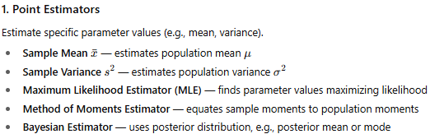
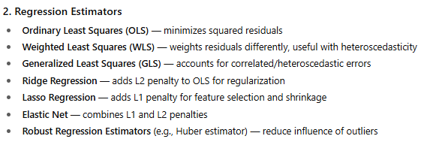
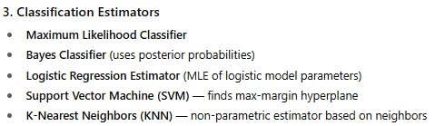

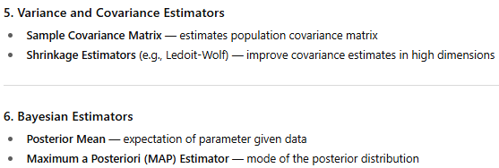
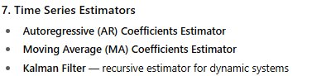

- Point Estimators
sample mean estimates population mean, how ?
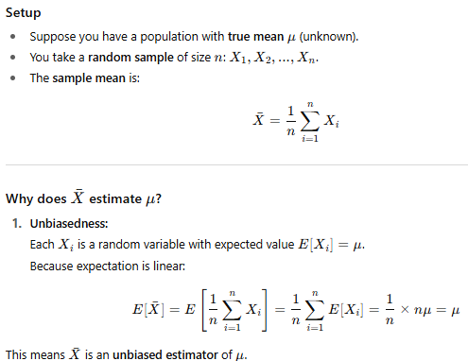
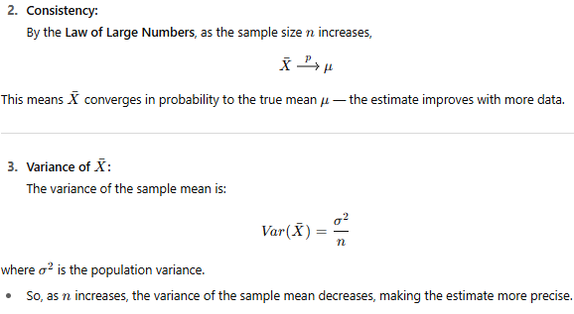
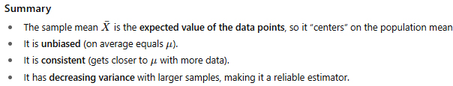

Let's go through a simple numeric example demonstrating how the sample mean estimates the population mean, and then a brief intuitive explanation of the Law of Large Numbers (LLN).
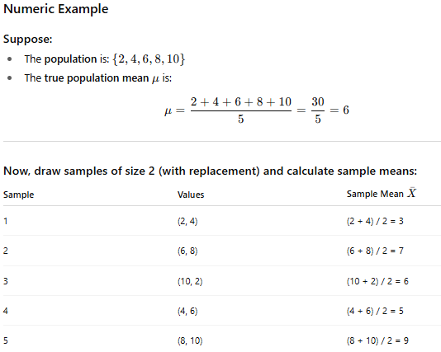
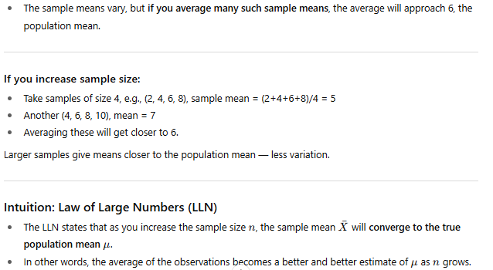
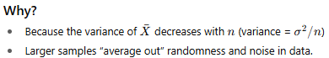
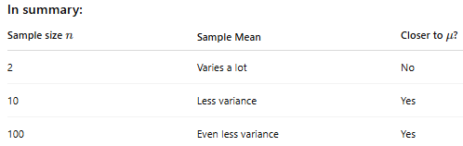

sample variance estimates population variance
Let me explain how the sample variance estimates the population variance and why we use the formula with n−1 in the denominator.
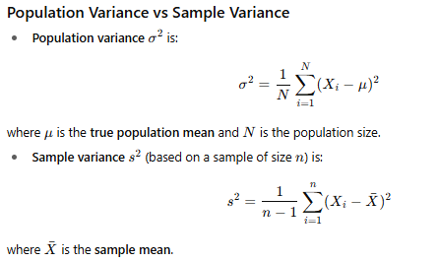
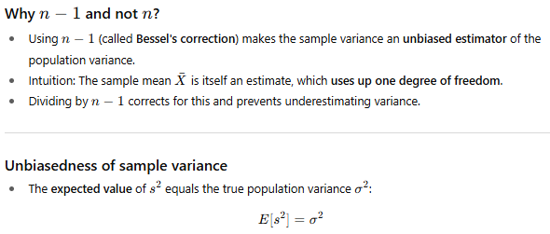
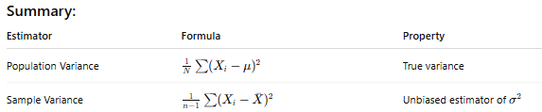

Here's a numerical example showing why dividing by n−1 (instead of n) gives an unbiased estimate of population variance.
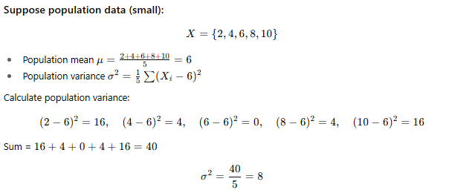
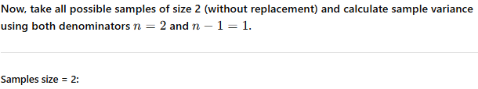
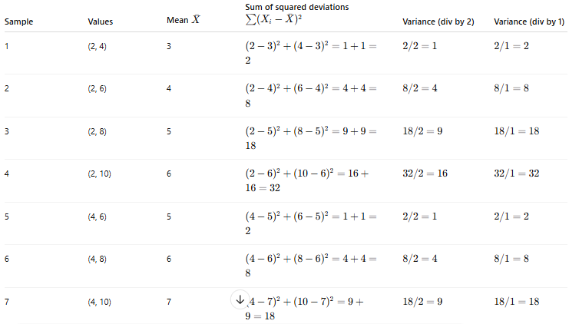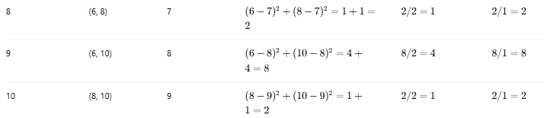

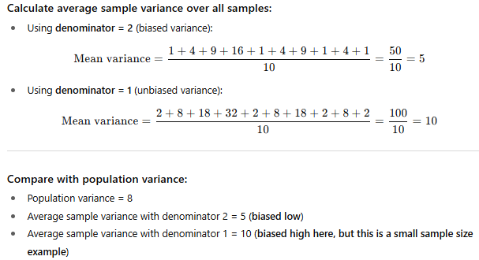
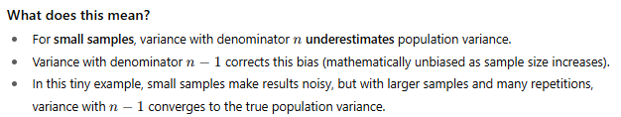

Maximum Likelihood Estimate:
https://www.youtube.com/watch?v=2PfGO753UHk
It is defined as the Joint probability of the given data for the given set of parameters.
Mathematically, It is same as finding the Probability of the data where we know the parameter beforehand. i.e
Likelihood of the parameter given the data= Probability of the data given the parameter
L(µ,data)=P(data,µ)
Even though mathematically they are found to be same, conceptually they are not..
Because, in Likelihood function L(µ,data), we have the data first, but we don’t know the original parameters of the data i.e. we don’t know which distribution is applicable for this data. So, we take the dummy parameters and start finding the probability of the data for this set of parameters
While in case of Probability P(data,µ), we actually know the distribution of the data i.e. we know the shape and parameters of the data and we want to find some probability of new data given the parameters.
So, we talk about Likelihood when we have the data first.
We talk about the probability when we have the distribution of the data and parameters first
Maximum Likelihood Estimation: Clear and Simple Explainer
https://www.youtube.com/watch?v=uN7yIhXxHHk
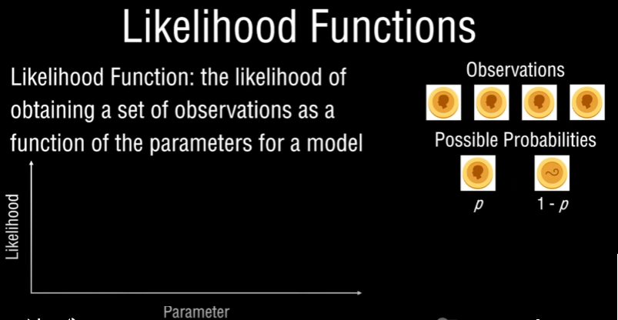

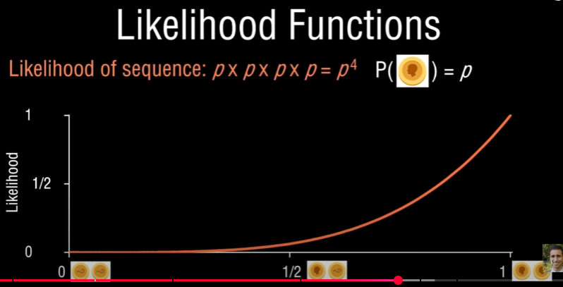
From the figure, If p increases, Likelihood increases.
If both sides of a coin are tails, then likelihood is 0
If both sides of a coin are heads, then likelihood is 100%
If sides of a coin are head/tails, then likelihood is 50%









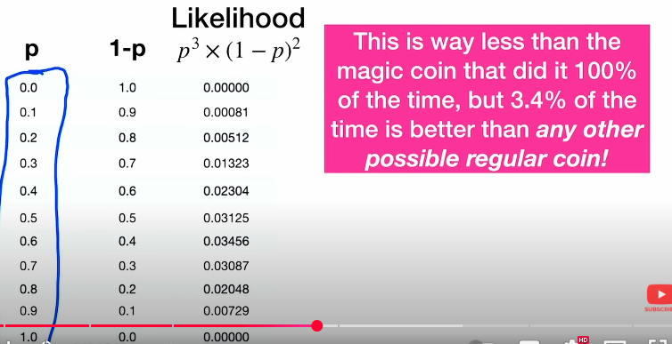

Now, Lets look at a Continuous Distribution…
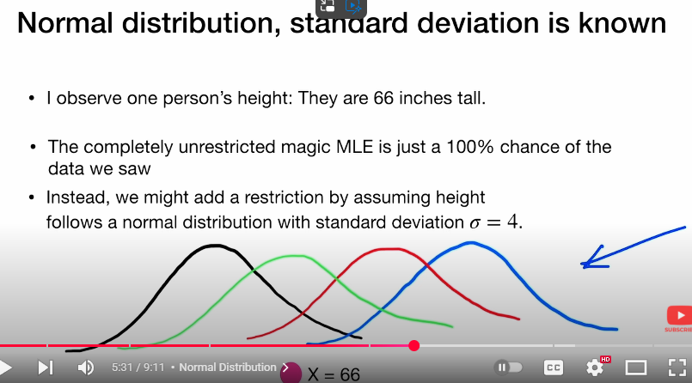
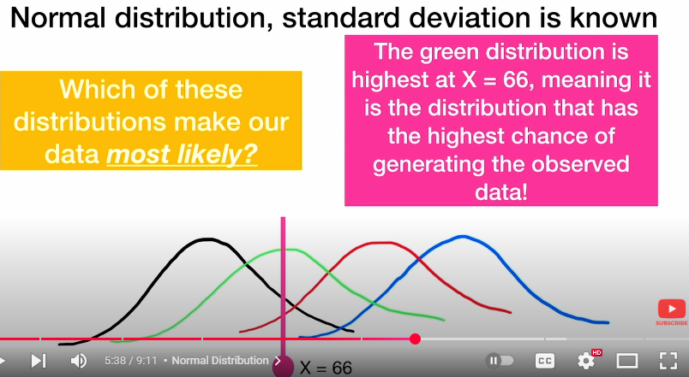
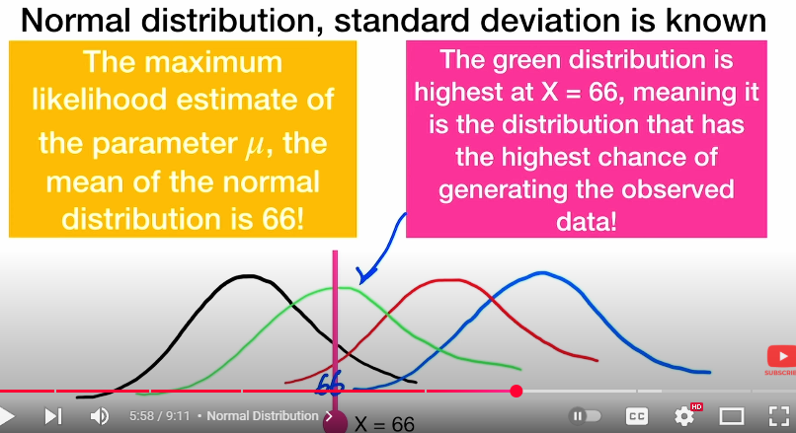
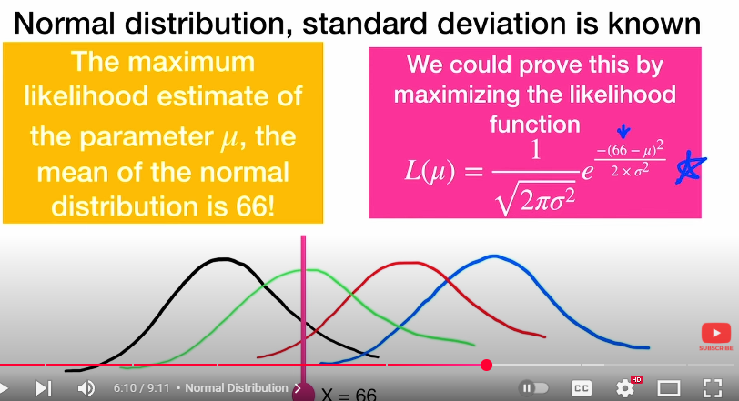
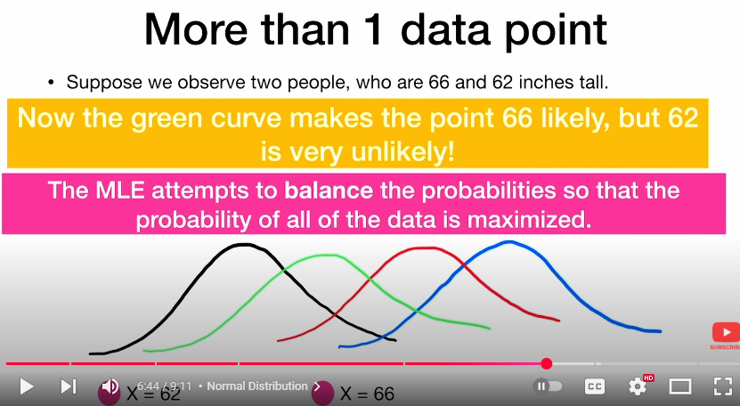



The Likelihood function is the Product of the Individual Probabilities

In one case, Area=1*9=9 Sq. units
In Second Case, Area=5*5 =25 Sq. Units
So we have maximized the area when we balance the Length and width. Similarly, we can get the maximum Likelihood we balance the Probabilities.
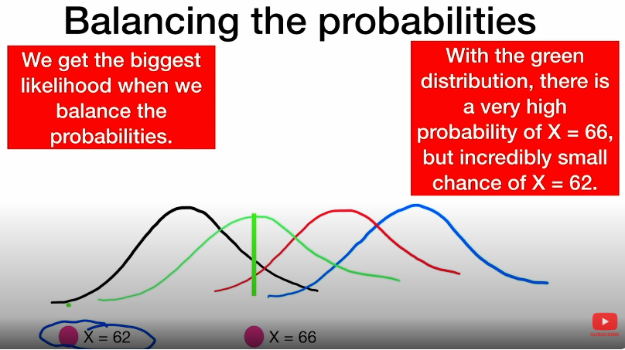
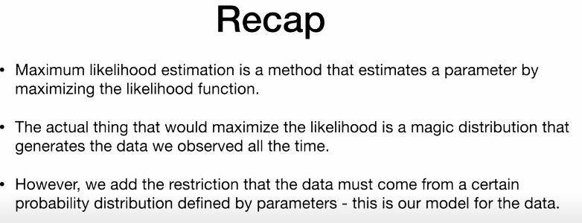


Probability Vs Likelihood
Probability vs. Likelihood ... MADE EASY!!!
https://www.youtube.com/watch?v=bXGjQnpGGIo

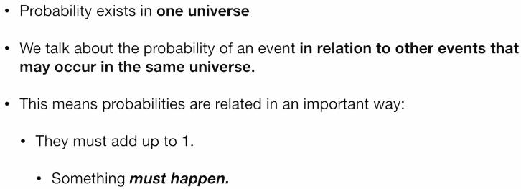

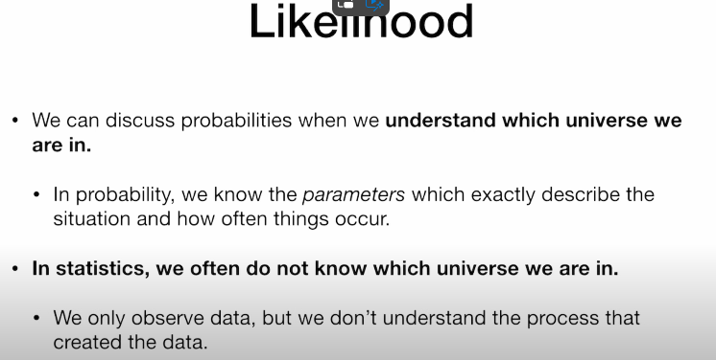
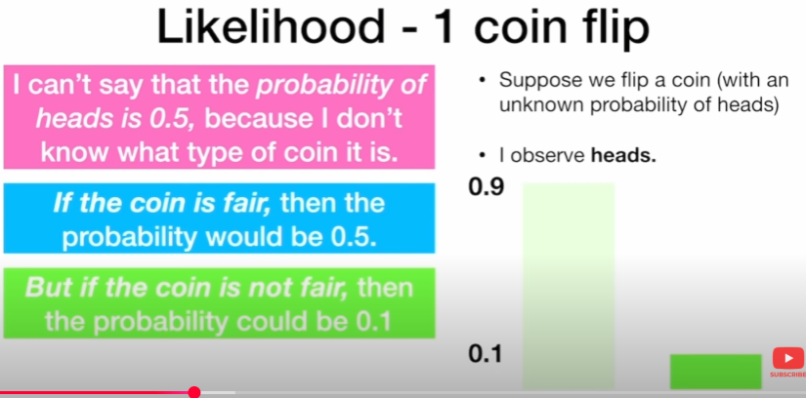

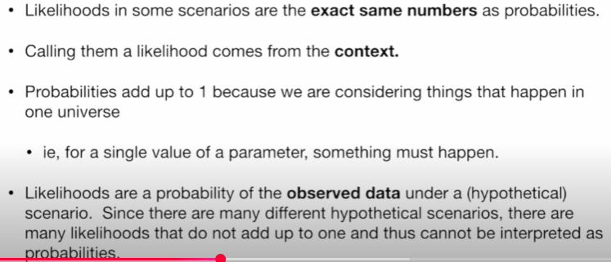
Probability adds up to 1 whereas Likelihood will not do so… as they have the possibility to occur in different scenarios/different distributions/different contexts




For Likelihood estimation, Following are the assumptions made
- Observations/events occurring are independent of each other.
- Observations/events are identically distributed.

Summary:
We have a model where the parameters are unknown, but we have the set of observations, and we are trying to map out how likely the observations would have occurred as a function of what the model parameters were.
Here, the outcomes and observations are set and known but the underlying model is not, that’s what we are trying to figure out.
According to Maximum Likelihood Estimation, what we want to do is,
For our model, select the parameters that maximizes this likelihood function
In simple, what is the value of P that maximized the Likelihood function.

Probability Vs Likelihood
Probability Vs Likelihood | Difference between Probability and Likelihood
https://www.youtube.com/watch?v=5TczDUBOH74
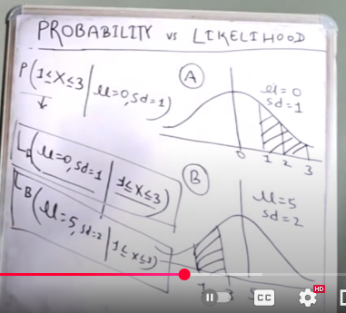
Consider the Hike % of two organizations below..
Question 1: What is the Probability of a Random employee chosen whose hike % is between 1% and 3% ?
How to write the above mathematically?
P(1<=Random Employee<=3 /Mean=0, SD=1)
Solution: Area under the curve in first chart
Now, what is Likelihood
Consider a Random Employee with hike % between 1% and 3%. What is the Likelihood of employee belonging to the above Distribution. If so what should be parameter values?
Mathematically , It is represented as
L(Mean=0,SD=1 /1<=Random Employee<=3)
If you Note carefully,
In the First Case, we are drawing the chance of occurrence of the Event. (Here the event refers to the employee having hike % between 1% and 3%)
In the Second Case, we are trying to estimate the chance of the employee whose hike % between 1% and 3% belonging to the above distribution (i.e. Distribution with Mean=0 and SD=1)
Now I can ask,
what is the chance of employee whose hike % between 1% and 3% belonging to the distribution (i.e. Distribution with Mean=5 and SD=2)
what is the chance of employee whose hike % between 1% and 3% belonging to the distribution (i.e. Distribution with Mean=4 and SD=1.25)
what is the chance of employee whose hike % between 1% and 3% belonging to the distribution (i.e. Distribution with Mean=2 and SD=2)
what is the chance of employee whose hike % between 1% and 3% belonging to the distribution (i.e. Distribution with Mean=2.5 and SD=1.75)

So, now, there are multiple Likelihoods for an employee belonging to Different Distribution?
Among these Likelihoods, which one opts for maximum value. That one is referred to as Maximum Likelihood

Summary:
In Probability, Parameters are fixed, event is varying (event refers to picking up the employee whose hike % between 1% and 3%)
In Likelihood, Event is fixed, Parameters are varying, (Try with different Parameter values to map the event in different distributions and find the maximum possible value which is referred as the maximum Likelihood)
We will have curves where likelihood will be more and we will have curves where likelihood will be less..
In simple, Likelihood is referred as what are the chances of happening this same event in different distributions on varying the parameter values..

L5/2 Maximum Likelihood and Maximum a Posteriori
https://www.youtube.com/watch?v=yH_xwGnW-ig
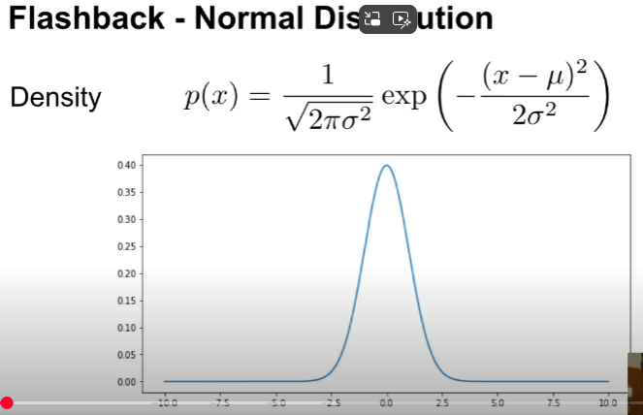
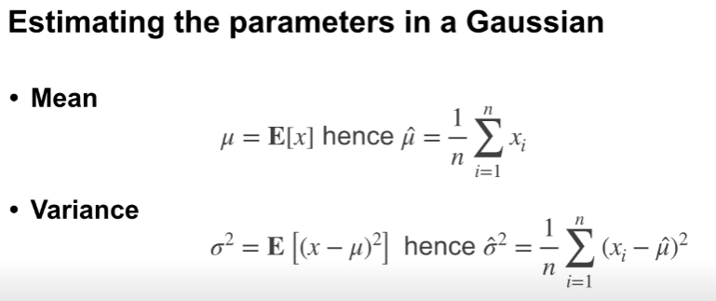
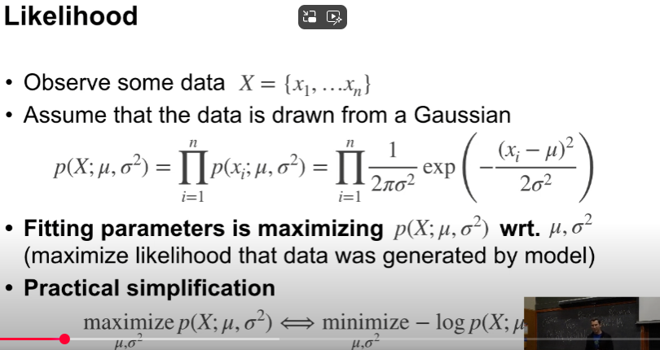

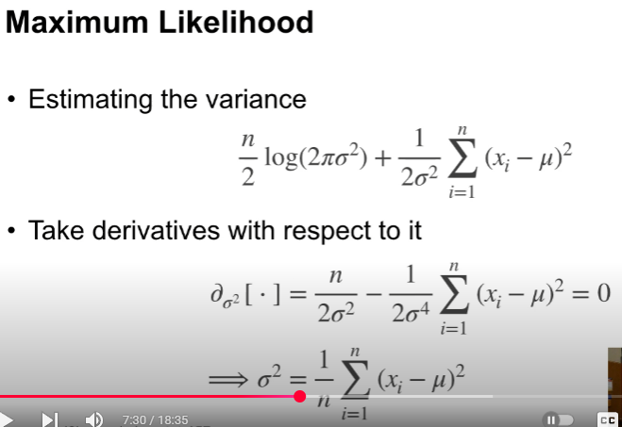
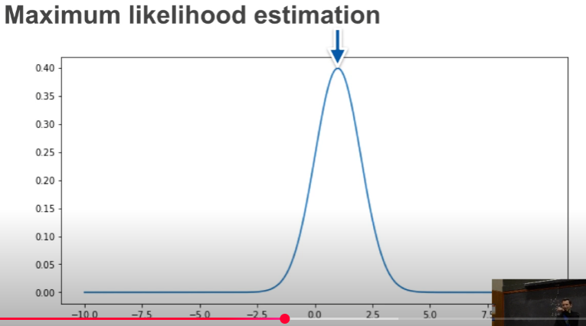
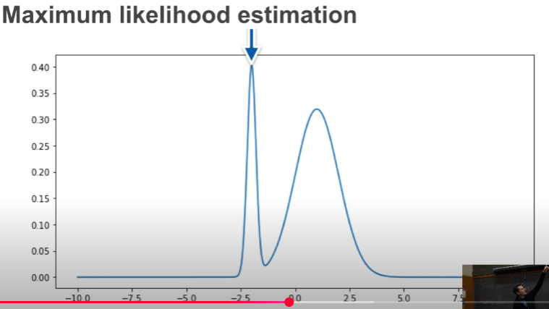
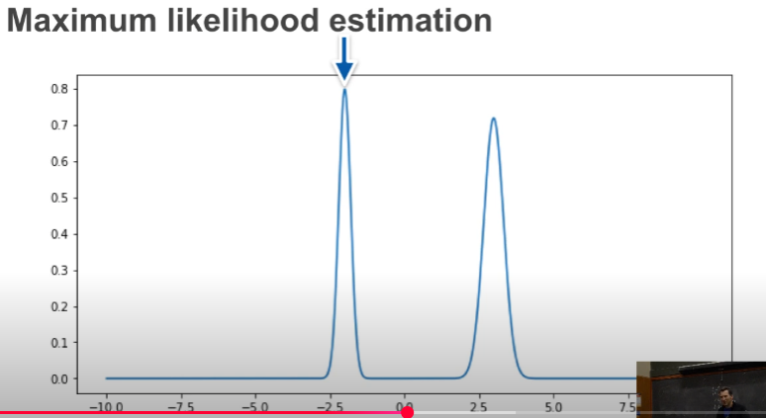

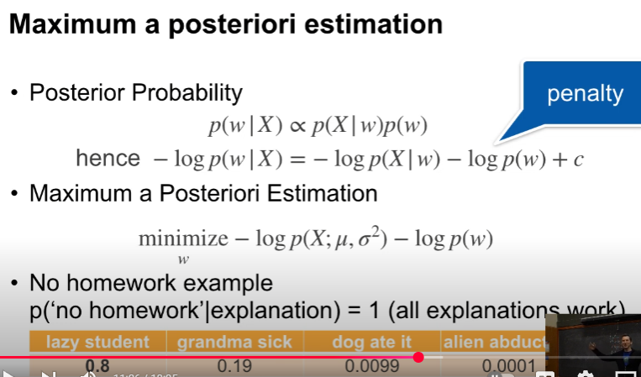

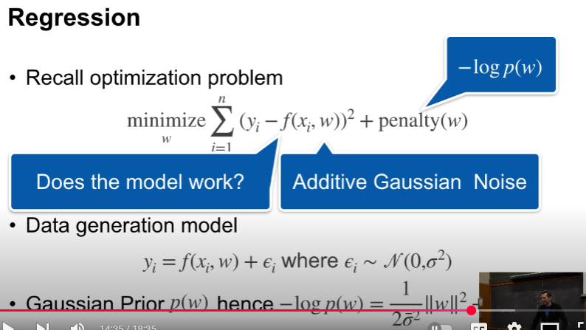
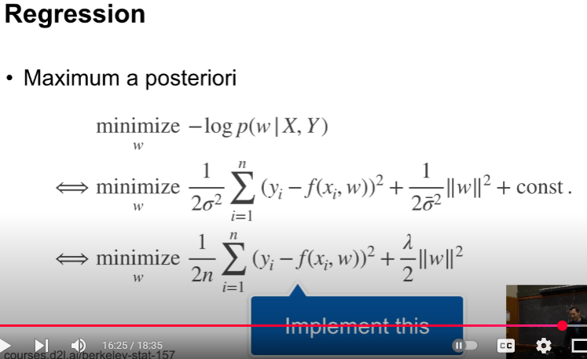

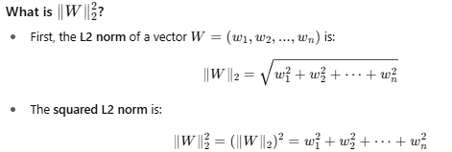
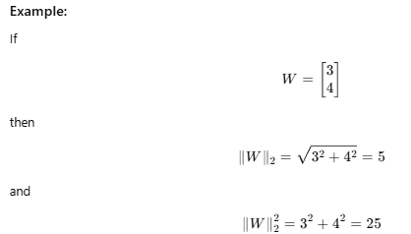

My Comment:
Note: The Observed data (for which Maximum Likelihood to be estimated ) should somehow follow any of the Probability distribution

Maximum Likelihood Estimation (MLE) is a fundamental statistical method used to estimate parameters of a probability model by maximizing the likelihood function — basically finding the parameters that make the observed data most probable.
Applications of Maximum Likelihood Estimation (MLE)
1. Statistical Modelling & Parameter Estimation
- Estimating parameters of common distributions:
  - Mean & variance of Gaussian (Normal) distribution
  - Rate parameter of Poisson distribution
  - Probability in Bernoulli or Binomial distributions
- Example: Estimating average height of a population assuming normally distributed heights.
2. Machine Learning
- Training probabilistic models by maximizing likelihood:
  - Logistic regression (classification)
  - Naive Bayes classifiers
  - Hidden Markov Models (HMMs)
  - Gaussian Mixture Models (GMMs)
- Example: Estimating weights in logistic regression by maximizing the likelihood of class labels given features.
3. Natural Language Processing (NLP)
- Estimating language models:
  - N-gram models for predicting next word probabilities
  - Word embeddings and probabilistic topic models
- Example: Using MLE to estimate probability of word sequences in text corpora.
4. Econometrics and Finance
- Estimating parameters in time-series models:
  - ARIMA models
  - GARCH models (volatility)
- Risk modeling, option pricing with probabilistic models.
5. Bioinformatics and Genetics
- Estimating mutation rates, allele frequencies, or gene expression parameters.
- Phylogenetic tree estimation using likelihood-based models.
6. Signal Processing
- Parameter estimation in models of signals corrupted by noise.
- Example: Estimating parameters of a Gaussian noise model to denoise data.
7. Computer Vision
- Object recognition, image segmentation using probabilistic models.
- Estimating parameters of models that explain pixel intensities or features.
8. Physics & Engineering
- Estimating system parameters in models of physical processes.
- Example: Estimating parameters of a model describing sensor readings.
9. Robotics and Control Systems
- State estimation (e.g., Kalman filters rely on likelihood maximization).
- Sensor fusion and parameter tuning in probabilistic robot models.
Field | Application Example
Statistics | Estimating mean/variance of data
Machine Learning | Logistic regression, HMM parameter estimation
NLP | Language modeling, text prediction
Finance | Time-series volatility modeling
Bioinformatics | Mutation rate estimation
Signal Processing | Noise parameter estimation
Computer Vision | Image segmentation
Physics/Engineering | System parameter identification
Robotics | State estimation and sensor fusion

Problem 1: MLE for Bernoulli Distribution
Problem:
You flip a coin 10 times and observe 7 heads. Estimate the probability θ of heads using MLE.
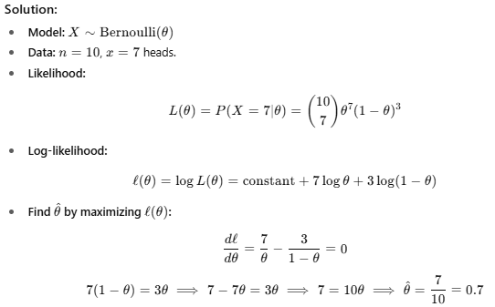

Problem 2: MAP estimation for Bernoulli with Beta prior
Problem:
Same data as above, but prior belief about θ is Beta(2,2). Find the MAP estimate.

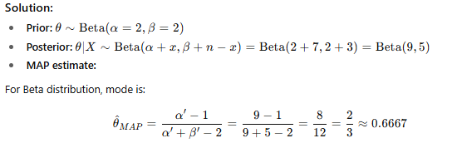

Problem 3: MLE for Poisson distribution
Problem:
You observe the following counts of emails received per hour over 5 hours: 3, 2, 4, 0, 1. Estimate the Poisson rate λ
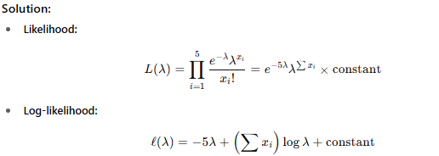
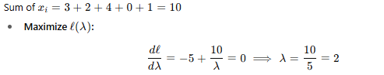
Problem 4: MAP estimation for Poisson with Gamma prior
Problem:
Same data as above. Prior for λ is Gamma with shape α=3 and rate β=1. Find MAP estimate.
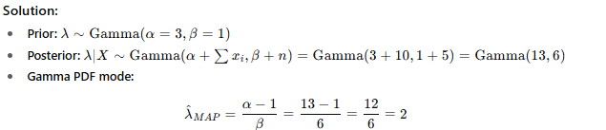
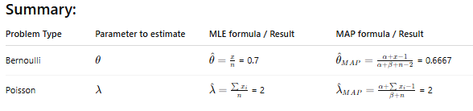

MLE and MAP estimation for Normal distribution

Normal Distribution
Suppose you have data samples:
and assume
1. Maximum Likelihood Estimation (MLE)
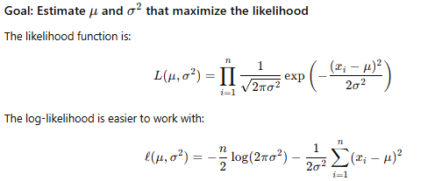
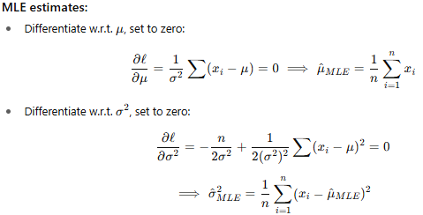
2. Maximum A Posteriori (MAP) Estimation
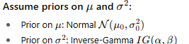
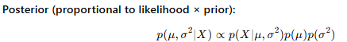
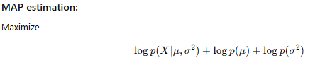
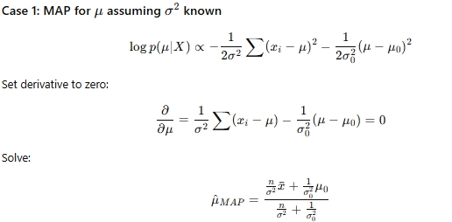
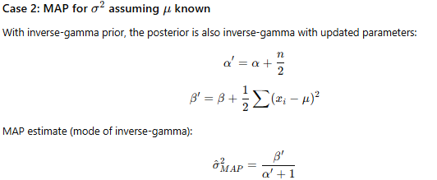
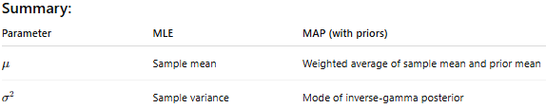

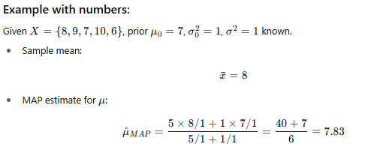

Methods of Moment Estimator
The Method of Moments estimates unknown parameters of a distribution by matching sample moments to theoretical moments.
In simpler terms:
Replace the unknown theoretical moments (like expected value, variance) with their sample equivalents, and solve the resulting equations to estimate parameters.

Feature | Method of Moments (MME) | Maximum Likelihood Estimation (MLE)
Simplicity | Easier to compute manually | Can be complex, especially with multiple parameters
Accuracy | Often less efficient | Asymptotically optimal (under regular conditions)
Existence | Always gives a solution (if moments exist) | MLE may not exist or be hard to solve
Robustness | Sensitive to outliers (like MLE) | Sensitive, but often better asymptotically

Method of Moments - GeeksforGeeks
https://www.geeksforgeeks.org/maths/method-of-moments/
The Method of Moments (MoM) is a statistical method that estimates population parameters by equating the sample moments to the population moments. MoM is widely applied in probability, statistics, and econometrics to obtain estimates of unknown probability distribution parameters.
What are Moments?
Moments describe the shape and characteristics of a probability distribution. For a random variable X, the r-th moment about the origin is defined as:
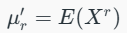
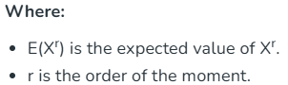

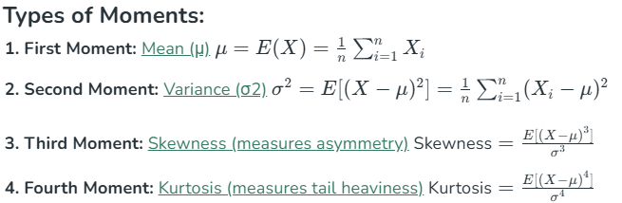
Steps of Moments Estimation
The Method of Moments involves the following steps:
Step 1: Define Population Moments
Define the population moments based on the assumed probability distribution. For a distribution with k parameters, the first k moments are used.
Step 2: Define Sample Moments
The sample moments are calculated using the sample data. The r-th sample moment is given by:
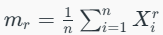
Step 3: Equate Sample Moments to Population Moments
Set the sample moments equal to the theoretical moments to form a system of equations.
Step 4: Solve for Parameters
Solve the system of equations to obtain estimates of the unknown parameters.
Method of Moments Estimation
1. Estimating Parameters of a Normal Distribution
Consider a normal distribution with mean μ and variance σ2. The first two population moments are:
The corresponding sample moments are:
By solving:
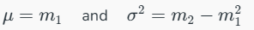
2. Estimating Parameters of an Exponential Distribution
For an exponential distribution with rate parameter λ, the first population moment is:
The sample moment is:
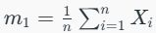
Setting the sample moment equal to the population moment gives:
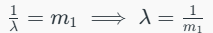
Comparison with Maximum Likelihood Estimation (MLE)

Feature | MoM | MLE
Effciency | Less efficient | More efficient
Bias | Can be biased | Asymptotically unbiased
Ease of Use | Easier | Requires optimization
Application | Simpler models | Complex models

Applications of Method of Moments
1. Parameter Estimation: Estimating the parameters of probability distributions, such as normal, exponential, Poisson, and binomial distributions.
2. Risk Modeling: Used in actuarial science and finance to estimate risk parameters.
3. Machine Learning and AI: Applied in generative models and Bayesian networks for parameter learning.
4. Economics and Econometrics: Estimation of economic models where moment conditions are specified.
Advantages of Method of Moments
1. Simplicity: Easy to implement and does not require complex optimization techniques.
2. Computational Efficiency: Faster than maximum likelihood estimation (MLE) for large datasets.
3. Flexibility: Can be applied to various distributions and models.

What Is a Bayesian Estimator?
A Bayesian estimator uses Bayes' Theorem to estimate unknown parameters by combining prior beliefs with observed data.
It doesn’t just give a single value—it gives a probability distribution over possible parameter values (called the posterior distribution).
In simple terms:
"Instead of guessing the most likely parameter from data alone (like MLE), I’ll update what I already believe about the parameter using the data I observed."
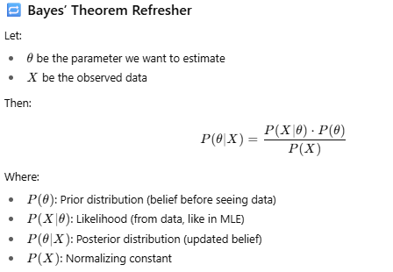
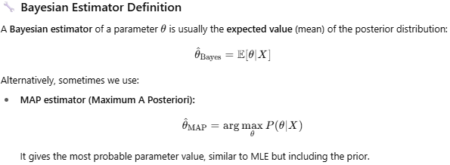
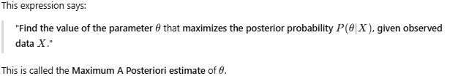
arg max stands for "argument of the maximum".
It means:
Find the value of θ that gives the highest value of the function P(θ∣X)
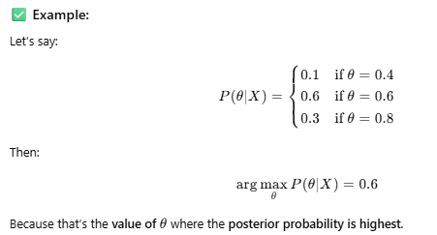
Be Careful: arg max gives the input, not the output.

What is a Bayesian Estimator?
Bayesian estimation is a method of estimating parameters of a statistical model using Bayes’ theorem.
Instead of finding a single “best” estimate (like in MLE), Bayesian estimation treats parameters as random variables and computes a posterior distribution over them.
The key formula:
- Prior: What you believe about the parameter before seeing the data.
- Likelihood: Probability of observed data given the parameter.
- Posterior: Updated belief about the parameter after seeing data.

Bayesian Estimator (MAP estimate):
The Bayesian estimator is often taken as the mode of the posterior distribution, called the Maximum A Posteriori (MAP) estimate:
This maximizes the posterior probability.
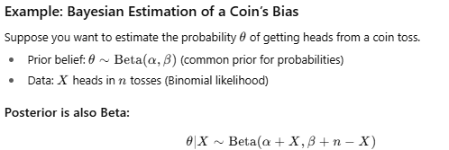
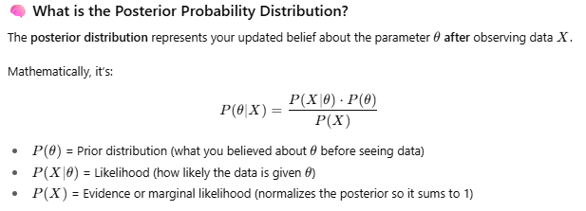

Why is the Posterior Important?
- It combines your prior knowledge and the new information from observed data.
- It gives a full probability distribution for θ, quantifying uncertainty.
- You can use it to make predictions, estimate parameters, or update beliefs as more data arrives.
Visual Intuition
- Before seeing data, your belief is spread according to the prior.
- After seeing data, the posterior "shapes" the prior based on how well different θ values explain the data.
- The posterior is often more "concentrated" (less uncertain) than the prior.

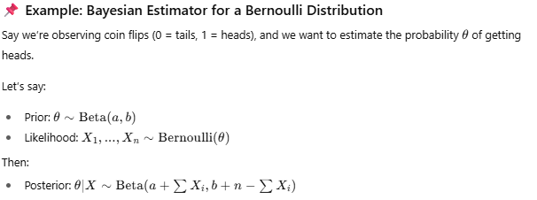
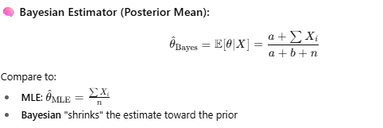

What are Maximum Likelihood (ML) and Maximum a posteriori (MAP)? ("Best explanation on YouTube")
https://www.youtube.com/watch?v=9Ahdh_8xAEI
Consider a linear equation y=ax+n
Where x and a could be
X=>Temparature from IOT device ; a= amplified factor
X=>Digital Signal a=> amplifier output
X=>Grid Coordinates in RADAR Tracking ;
n=> Additive white Gaussian Noise

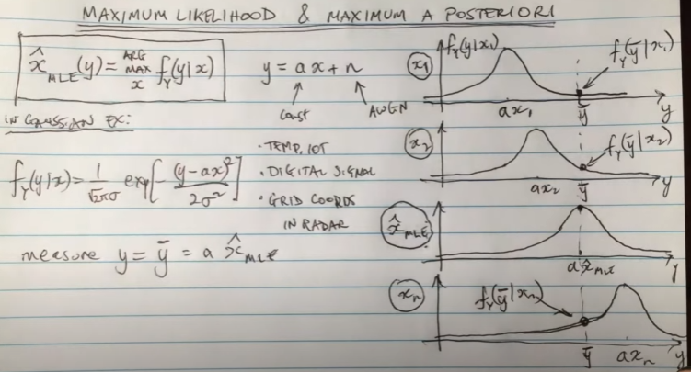

PB65: Maximum A Posteriori (MAP) Estimation
https://www.youtube.com/watch?v=845xlSrrB38
Given a value of a Random variable Y, what is the best estimate of a Random Variable X?
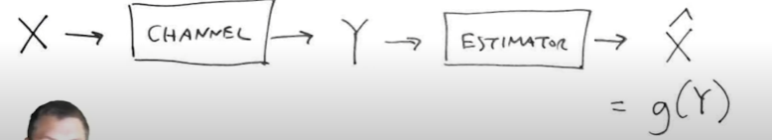
Maximum a Posteriori estimations says that given a value of Y, what value of X is most likely to be occurred?

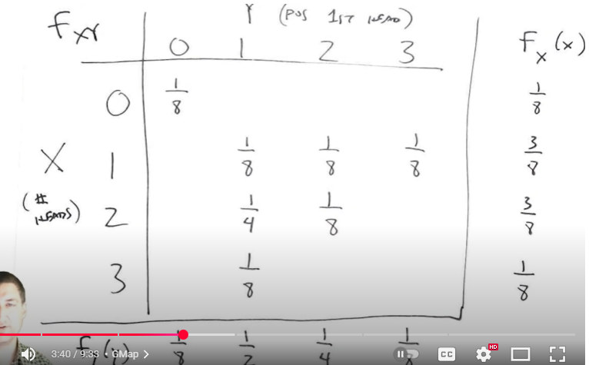

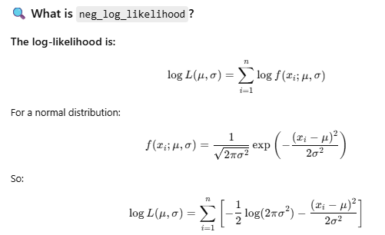

🚀 Purpose in MLE:
We use this function with an optimizer to find the values of μ and σ that minimize the negative log-likelihood, which is equivalent to maximizing the likelihood.

why are we taking negative log in maximum likelihood estimation ?
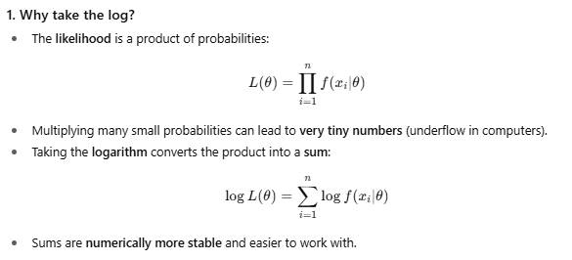
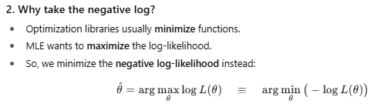


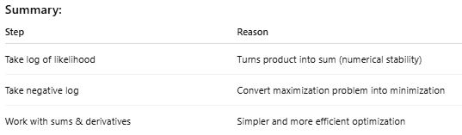

how negative log converts maximization problem into minimization. Example
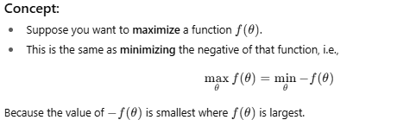
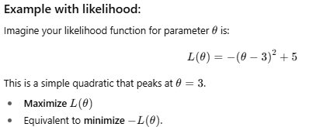

Interpreting the results of Linear Regression using OLS Summary - GeeksforGeeks
https://www.geeksforgeeks.org/machine-learning/interpreting-the-results-of-linear-regression-using-ols-summary/

Regression Estimators:
Ordinary Least Squares (OLS)
Ordinary Least Squares (OLS) is a fundamental statistical technique used to estimate the relationship between one or more independent variables (predictors) and a dependent variable (outcome).it is one of the most broadly used methods for linear regression analysis. the important thing idea in the back of OLS is to locate the line (or hyperplane, within the case of a couple of variables) that minimizes the sum of squared errors among the located records factors and the expected values. this technique is broadly relevant in fields such as economics, biology, meteorology, and greater.
Goal of OLS
- Minimize the sum of squared differences between the observed values and the predicted values.
- Find the best-fitting line (or hyperplane for multiple variables) by reducing the residuals.

How OLS Works
Ordinary Least Squares (OLS) regression assumes a linear relationship between the dependent (target) variable and the independent (predictor) variables. The model aims to estimate the coefficients (also called betas) that provide the best fit to the data. The general formula for an OLS regression model is:
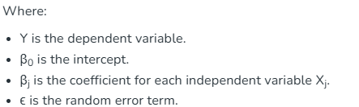
Mathematical Approach
The OLS approach includes solving for the coefficients using matrix algebra. the important thing system for the coefficients is:

The predicted values of Y (denoted y∗) are calculated as:
OLS then minimizes the sum of the squared variations between the determined values and the anticipated values, making sure the version offers the quality fit to the information.
Assumptions of OLS
For OLS regression to provide valid estimates, several assumptions must be met:
- Independence of Observations: Each observation must be independent of others. For example, the height of a person does not depend on the height of the person measured just before them.
- Homoscedasticity: The variance of the residuals (errors) should be constant across all levels of the independent variables. If the variance of errors increases or decreases with the values of the independent variables, the model might not be reliable.
- Normality of Residuals: The residuals should follow a normal distribution. This assumption is necessary for valid hypothesis testing and confidence intervals.
- Linearity: The relationship between the independent and dependent variables should be linear. If the relationship is not linear, OLS will not provide accurate predictions.
- No Multicollinearity: The independent variables should not be highly correlated with each other. If they are, it becomes difficult to separate their individual effects on the dependent variable.

OLS in Practice
Example: Predicting Plant Height Based on Sun Exposure
Consider a scenario where you want to predict the height of plants based on the number of days they have been exposed to the sun. In this case:
- Y is the height of the plants (dependent variable).
- X is the number of days spent in the sun (independent variable).
If the plants start at 30 cm and grow 0.1 cm per day, the equation becomes:
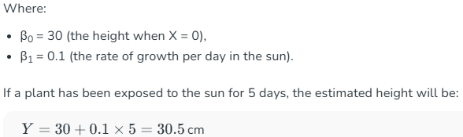
The error term ϵ accounts for random variation, as real data often includes measurement errors or other unaccounted factors.
Evaluation of OLS Models
The performance of an OLS regression model is typically evaluated using the following metrics:
- R-squared (R²): This statistic indicates how well the model explains the variance in the dependent variable. An R² value close to 1 means the model explains most of the variation, while a value closer to 0 indicates a poor fit.
- Adjusted R-squared: This adjusts the R² value for the number of explanatory variables, providing a more accurate measure when comparing models with different numbers of predictors.
- P-values: These assess the statistical significance of each coefficient. A small p-value (typically less than 0.05) indicates that the corresponding variable is statistically significant.
- F-statistic: This tests the overall significance of the regression model. A high F-statistic means the model as a whole is likely significant.
- Standard Errors: These measure the variability in the coefficient estimates. Smaller standard errors suggest more precise estimates.

Strengths and Limitations of OLS
Strengths
- Simplicity and Interpretability: Easy to implement and interpret the coefficients.
- Efficiency: Provides the best linear unbiased estimates (BLUE) under the Gauss-Markov assumptions.
- Widely Used: Applicable in finance, economics, biology, and various fields.

Limitations
- Sensitivity to Outliers: OLS is sensitive to outliers, which can distort the model.
- Multicollinearity Issues: Highly correlated features can reduce the reliability of the coefficient estimates.
- Limited to Linear Relationships: Cannot capture nonlinear patterns effectively.
Real-World Applications of OLS
1. Finance
- Predicting stock prices based on past performance.
- Modeling the relationship between interest rates and inflation.
2. Economics
- Estimating the impact of GDP growth on unemployment rates.
- Analyzing consumer spending patterns.
3. Healthcare
- Analyzing the relationship between BMI and blood pressure.
- Predicting hospital readmission rates based on patient demographics.
4. Marketing
- Estimating advertising effectiveness on product sales.
- Analyzing the impact of price changes on demand.

Interpreting the results of Linear Regression using OLS Summary
Linear regression is a popular method for understanding how different factors (independent variables) affect an outcome (dependent variable. The Ordinary Least Squares (OLS) method helps us find the best-fitting line that predicts the outcome based on the data we have. In this article we will break down the key parts of the OLS summary and how to interpret them in a way that's easy to understand. Many statistical software options, like MATLAB, Minitab, SPSS, and R, are available for regression analysis, this article focuses on using Python.
Understanding Components of OLS Summary
The OLS summary report is a detailed output that provides various metrics and statistics to help evaluate the model's performance and interpret its results. Understanding each one can reveal valuable insights into your model's performance and accuracy. The summary table of the regression is given below for reference, providing detailed information on the model's performance, the significance of each variable, and other key statistics that help in interpreting the results. Here are the key components of the OLS summary:
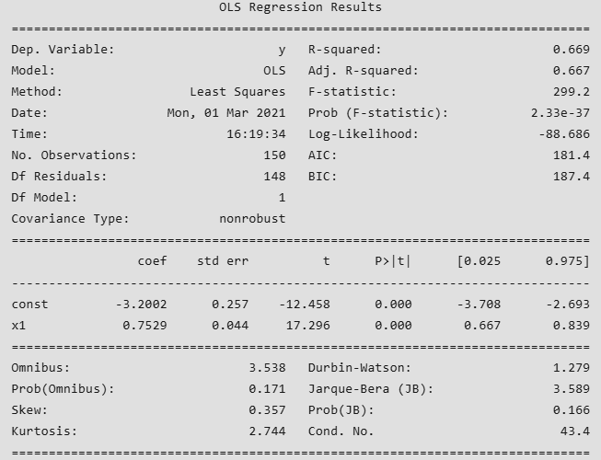
The Header Section: Dependent Variable and Model Information
- Dependent Variable and Model: The dependent variable (also known as the explained variable) is the variable that we aim to predict or explain using the independent variables. The model section indicates that the method used is Ordinary Least Squares (OLS), which minimizes the sum of the squared errors between the observed and predicted values.
- Number of observations: The number of observation is the size of our sample, i.e. N = 150.
- Degrees of freedom(df). Degree of freedom is the number of independent observations on the basis of which the sum of squares is calculated. Degrees of freedom, Df =N−K
Where, N = sample size(no. of observations) and K = number of variables + 1 (including the intercept).
Coefficient Interpretation: Standard Error, T-Statistics, and P-Value Insights
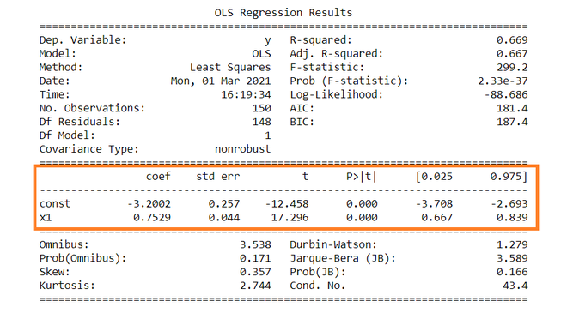
- Constant term: The constant terms is the intercept of the regression line. In regression we omits some independent variables that do not have much impact on the dependent variable, the intercept tells the average value of these omitted variables and noise present in model. For example, in the regression equation Y=5.0+0.75XY=5.0+0.75X , the constant term (intercept) of 5.0 indicates that when X=0, the predicted value of Y is 5.0, representing the baseline level influenced by omitted factors.
- Coefficient term: The coefficient term tells the change in Y for a unit change in X. For Example, if X rises by 1 unit then Y rises by 0.7529.
- Standard Error of Parameters: Standard error is also called the standard deviation. It is a measure of how much the coefficient estimates would vary if the same model were estimated with different samples from the same population. Larger standard errors indicate less precise estimates. Standard error is calculated by as:
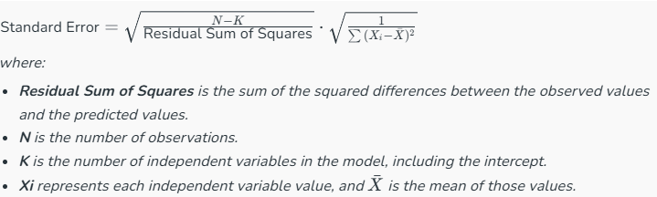

This formula provides a measure of how much the coefficient estimates vary from sample to sample.

- T-Statistics and P-Values:
  - The t-statistics are calculated by dividing the coefficient by its standard error. These values are used to test the null hypothesis that the coefficient is zero (i.e., the independent variable has no effect on the dependent variable).
  - The p-values associated with these t-statistics indicate the probability of observing the estimated coefficient (or a more extreme value) if the null hypothesis were true. A p-value below a certain significance level (usually 0.05) suggests that the coefficient is statistically significant, meaning the independent variable has a significant effect on the dependent variable.

- Confidence Intervals: The confidence intervals give a range within which the true coefficient likely falls, with a certain level of confidence (usually 95%).
  - If a confidence interval includes zero, it means there’s a chance the variable might not actually impact the outcome.
  - If zero isn’t in the interval, it’s more likely that the variable genuinely affects the outcome.

3. Evaluating Model Performance: Goodness of Fit Metrics

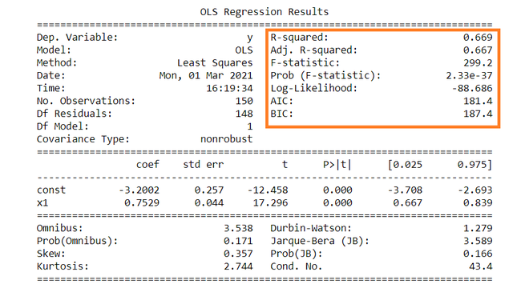
- R-Squared (R²) : R-squared measures the proportion of the variance in the dependent variable that is explained by the independent variables. It ranges from 0 to 1, where 1 indicates that the model explains all the variance.

- Adjusted R-Squared: Adjusted R-squared is a modified version of R-squared that adjusts for the number of independent variables in the model, providing a more accurate measure of the model's explanatory power when comparing models with different numbers of variables.
  - For example, an R-squared value of 0.669 means that about 66.9% of the variance in the dependent variable is explained by the model.
  - If the adjusted R-squared decreases when adding more variables, it suggests that the additional variables do not contribute significantly to the model and may be omitted.

- F-Statistic and Prob(F-Statistic): The F-statistic is used to test the overall significance of the model. The null hypothesis is that all coefficients (except the intercept) are zero, meaning the model does not explain any variance in the dependent variable. The p-value associated with the F-statistic indicates the probability of observing the F-statistic (or a more extreme value) if the null hypothesis were true. A small p-value (typically less than 0.05) indicates that the model is statistically significant, meaning at least one of the independent variables has a significant effect on the dependent variable.

4. Testing Model Assumptions with Diagnostics
The remaining terms are not often used. Ordinary Least Squares (OLS) summary provides several diagnostic checks to help assess specific assumptions about the data. Terms like Skewness and Kurtosis tells about the distribution of data. Below are key diagnostics included in the OLS summary:
- Omnibus: The Omnibus test evaluates the joint normality of the residuals. A higher value suggests a deviation from normality.
- Prob(Omnibus): This p-value indicates the probability of observing the test statistic under the null hypothesis of normality. A value above 0.05 suggests that we do not reject the null hypothesis, implying that the residuals may be normally distributed.
- Jarque-Bera (JB): The Jarque-Bera test is another test for normality that assesses whether the sample skewness and kurtosis match those of a normal distribution.
- Prob(JB): Similar to the Prob(Omnibus), this p-value assesses the null hypothesis of normality. A value greater than 0.05 indicates that we do not reject the null hypothesis.
- Skew: Skewness measures the asymmetry of the distribution of residuals. A skewness value close to zero indicates a symmetrical distribution, while positive or negative values indicate right or left skewness, respectively.
- Kurtosis: Kurtosis measures the "tailedness" of the distribution. A kurtosis value of 3 indicates a normal distribution, while values above or below suggest heavier or lighter tails, respectively.
- Durbin-Watson: This statistic tests for autocorrelation in the residuals from a regression analysis. Values close to 2 suggest no autocorrelation, while values less than 1 or greater than 3 indicate positive or negative autocorrelation, respectively.
- Cond. No. The condition number assesses multicollinearity, where values above 30 suggest potential multicollinearity issues among the independent variables.
Skewness and kurtosis for the normal distribution are 0 and 3 respectively. These diagnostic tests are essential for validating the reliability of a linear regression model, helping ensure that the model's assumptions are satisfied.

What is Ordinary Least Squares (OLS)?
- OLS is a method to estimate the parameters (coefficients) of a linear regression model.
- It finds the coefficients β that minimize the sum of squared residuals between observed and predicted values.

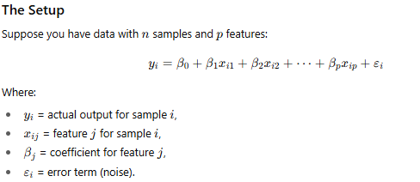

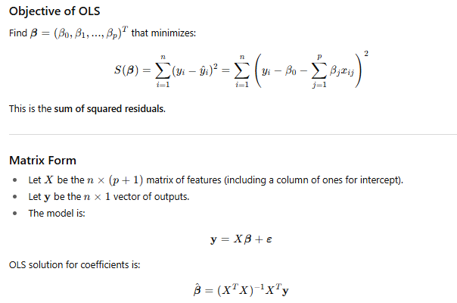
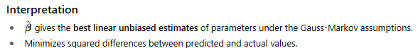

Let’s step through OLS with multiple features using a simple example and the matrix form.
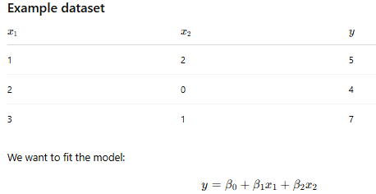
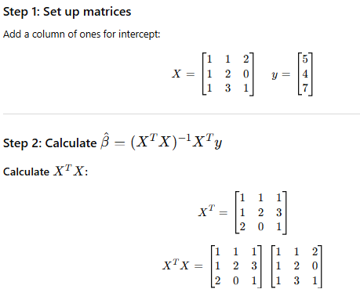
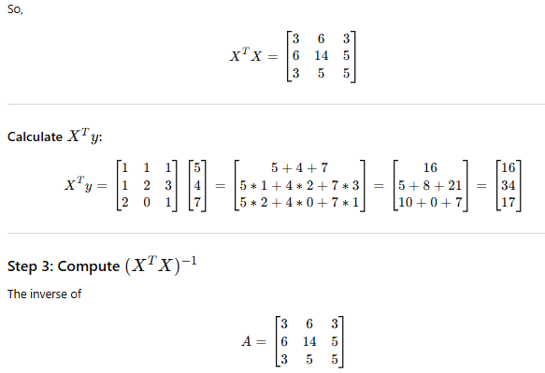
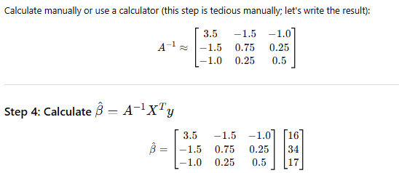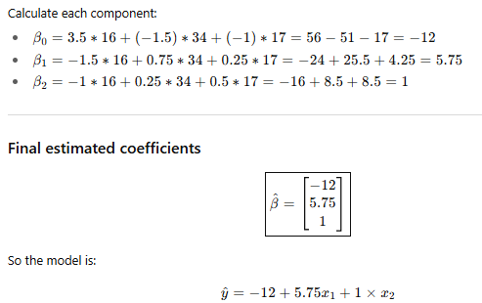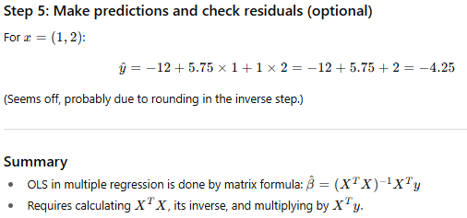
Gauss-Markov Theorem
What is it?
The Gauss-Markov theorem states that, under certain assumptions, the Ordinary Least Squares (OLS) estimator is the Best Linear Unbiased Estimator (BLUE) for the coefficients in a linear regression model.

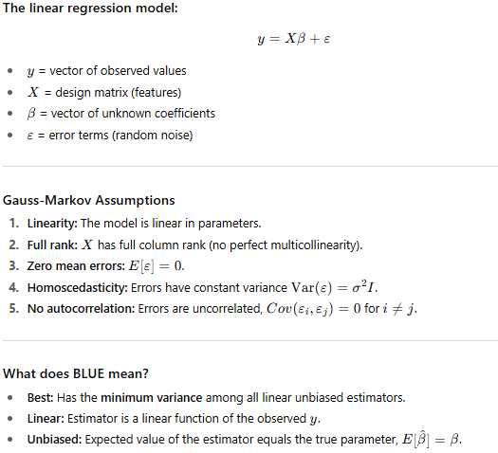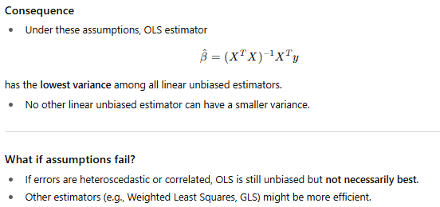

Intuition
OLS uses all available information in a linear way to produce the most precise unbiased estimates possible — under the assumptions.

What is Heteroscedasticity?
- Heteroscedasticity refers to the situation in a regression model where the variance of the errors (residuals) is not constant across all levels of the independent variables.
- In other words, the spread or "scatter" of residuals changes depending on the value of the predictor(s).

Aspect | Homoscedasticity | Heteroscedasticity
Error variance | Constant across all values of predictors | Varies with predictors
Residual plot | Residuals form a random scatter with equal spread | Residuals show funnel shape or patterns
Assumption in OLS | Required for Gauss-Markov theorem (OLS is BLUE) | Violates assumption, leading to inefficient OLS estimates

Why is it important?
- When heteroscedasticity exists, OLS estimates remain unbiased but:
  - The standard errors are incorrect, which means hypothesis tests (t-tests, F-tests) and confidence intervals can be misleading.
  - The OLS estimator is no longer the Best Linear Unbiased Estimator (BLUE).
  - This affects reliability of inference.

How to detect heteroscedasticity?
- Residual plots: Plot residuals vs predicted values; look for patterns or “funnel shapes.”
- Breusch-Pagan test, White test: Statistical tests for heteroscedasticity.

How to fix it?
- Use robust standard errors (heteroscedasticity-consistent standard errors).
- Transform dependent variable (e.g., log transformation).
- Use Weighted Least Squares (WLS) or Generalized Least Squares (GLS).
- Model the variance explicitly if possible.
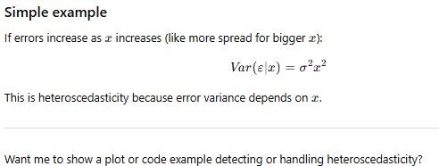

Breusch-Pagan test

The Breusch-Pagan test is a popular statistical test used to detect heteroscedasticity in a regression model’s residuals. In other words, it checks whether the variance of the errors depends on the values of the independent variables.


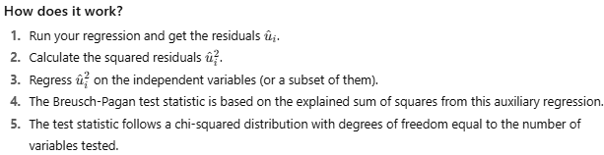
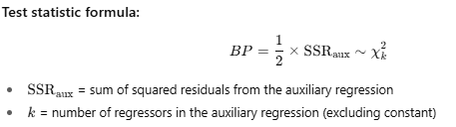
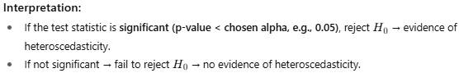

Python Code to Test Heteroscedasticity:
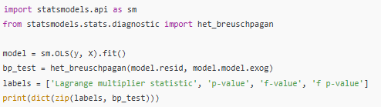

Breusch-Pagan Test: Step-by-Step with Math

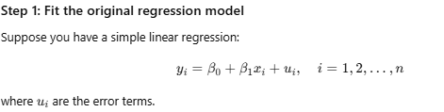

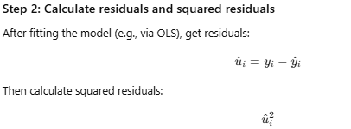
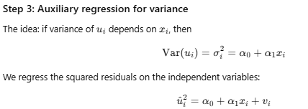
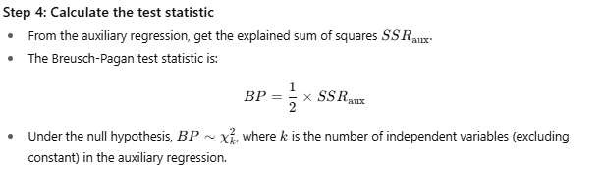



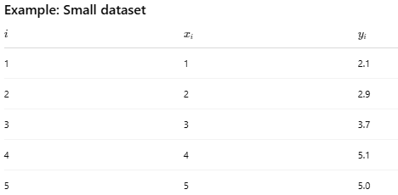

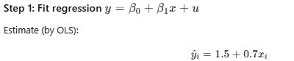

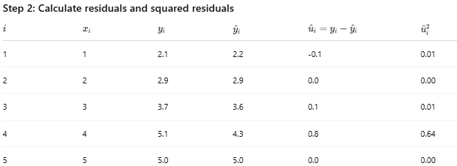

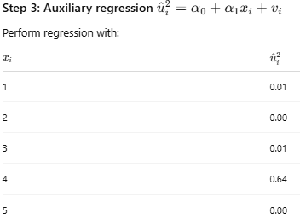

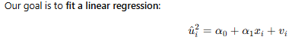
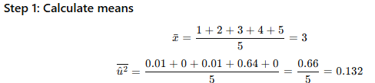
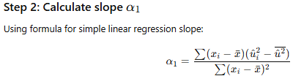
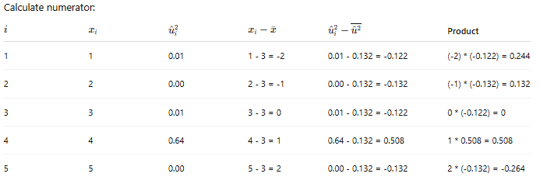

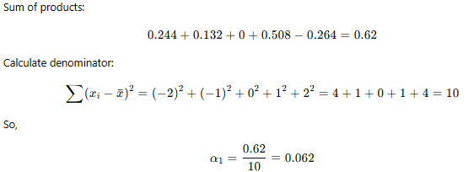
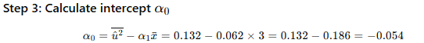

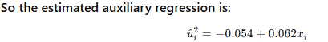
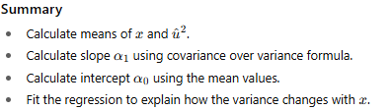

So,

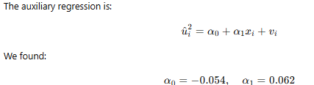

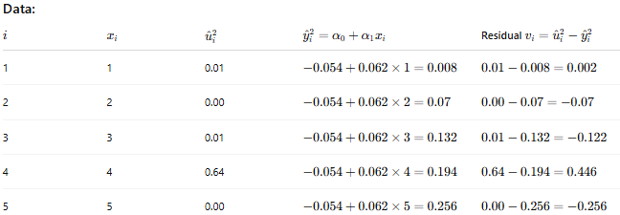

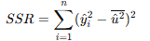

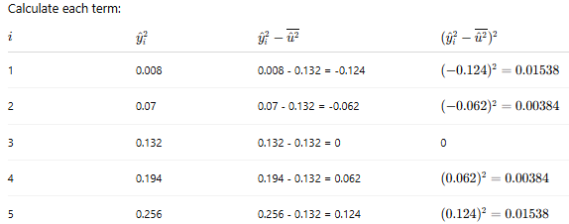

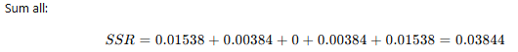

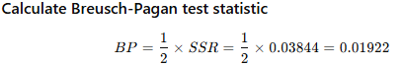

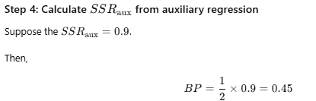


Thing to Know :

Skewness
What is Skewness?
Skewness measures the asymmetry of a probability distribution or dataset around its mean.
- If the distribution is perfectly symmetric, skewness is 0.
- If the distribution has a longer tail on the right (positive side), it’s positively skewed (right-skewed).
- If the distribution has a longer tail on the left (negative side), it’s negatively skewed (left-skewed).
Visual intuition
- Positive skew: Most data clustered on the left, tail stretches right.
- Negative skew: Most data clustered on the right, tail stretches left.
- Symmetric distribution: Balanced tails both sides.

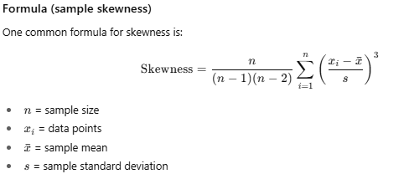

Interpretation
- Skewness > 0: Right-skewed; mean > median > mode
- Skewness < 0: Left-skewed; mean < median < mode
- Skewness ≈ 0: Symmetrical distribution; mean ≈ median ≈ mode

symmetrical distribution
What is a Symmetrical Distribution?
A symmetrical distribution is a type of probability distribution where the left side is a mirror image of the right side around the center (usually the mean or median).
In other words, if you fold the distribution plot at its center, the two halves would line up perfectly.
Key points about symmetrical distributions:
- Mean = Median = Mode — All three measures of central tendency are equal or very close.
- The tails on both sides are equally long.
- The shape on one side matches the shape on the other side.

Examples of symmetrical distributions:
- Normal distribution (bell curve) — the classic example.
- Uniform distribution — equal probability for all outcomes (a flat line).


This “bell-shaped” curve is perfectly symmetrical around the center.
Why is symmetry important?
- Many statistical tests assume data is symmetric (like t-tests, ANOVA).
- Symmetry implies no skewness (skewness = 0).
- Easier to model and interpret.

Kurtosis
What is Kurtosis?
Kurtosis is a statistical measure that describes the “tailedness” or peakedness of a probability distribution compared to a normal distribution.
It tells you whether the data have:
- Heavy tails (more outliers than normal),
- Light tails (fewer outliers),
- Or tails similar to the normal distribution.

Types of kurtosis:
- Mesokurtic
  - Kurtosis ≈ 3 (or excess kurtosis ≈ 0)
  - Similar to the normal distribution in terms of tail thickness.
  - Example: Normal distribution.
- Leptokurtic
  - Kurtosis > 3 (excess kurtosis > 0)
  - Heavy tails, more extreme outliers.
  - Distribution is more peaked with fatter tails.
- Platykurtic
  - Kurtosis < 3 (excess kurtosis < 0)
  - Light tails, fewer outliers.
  - Flatter peak than normal distribution.

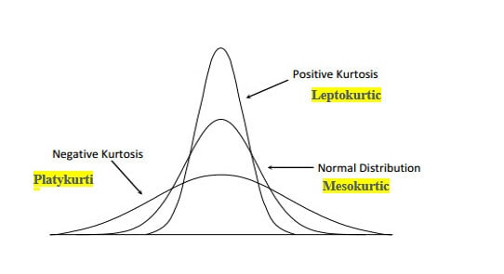

Visual intuition

Distribution type | Shape | Tail behavior
Mesokurtic | Moderate peak | Normal tails
Leptokurtic | Sharp peak | Fat tails (more outliers)
Platykurtic | Flat peak | Thin tails (fewer outliers)

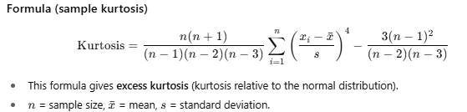
Why does kurtosis matter?
- High kurtosis indicates risk of extreme outcomes (important in finance, quality control).
- Helps to understand the distribution’s shape beyond just variance and skewness.
- Influences assumptions of many statistical models.

Joint normality
What is Joint Normality?
Joint Normality (or Multivariate Normality) refers to a situation where a set of two or more random variables have a joint distribution that is multivariate normal.
In simpler terms:
- Each variable individually follows a normal distribution,
- But also their combined behavior follows a specific kind of normal distribution,
- Characterized by a mean vector and a covariance matrix.

Why is Joint Normality important?
- It generalizes the normal distribution to multiple dimensions.
- Many multivariate statistical methods (e.g., multivariate regression, principal component analysis, discriminant analysis) assume joint normality.
- It allows us to understand relationships and correlations between variables while maintaining a “normal” structure.
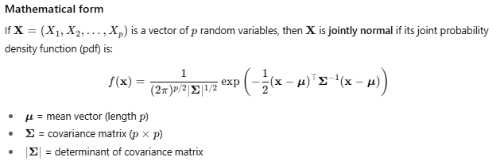
Key properties of jointly normal variables
- Any linear combination of jointly normal variables is also normally distributed.
- If variables are uncorrelated, they are also independent (which is generally not true for non-normal distributions).
- The shape of the joint distribution is an ellipsoid in p-dimensional space.

Visual intuition (2 variables)
If you plot two jointly normal variables X and Y:
- The scatter plot looks like a “cloud” shaped like an ellipse.
- The orientation of the ellipse reflects the correlation between variables.
- The density contours of their joint distribution are elliptical.

multicollinearity
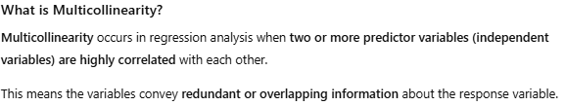
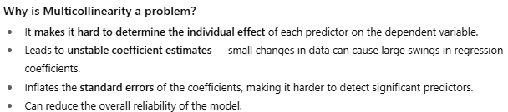
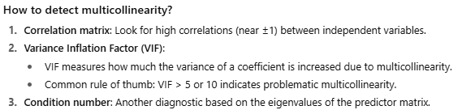
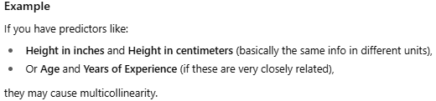

End: Thing to Know :

Practical Application: Case Study Interpretation
In this section, we will explore a practical application of Ordinary Least Squares (OLS) regression through a case study on predicting house prices. We will break down the OLS summary output step-by-step and offer insights on how to refine the model based on our interpretations with the help of python code that demonstrates how to perform Ordinary Least Squares (OLS) regression to predict house prices using the statsmodels library. This code includes the steps to fit the model, display the summary output, and interpret key metrics.
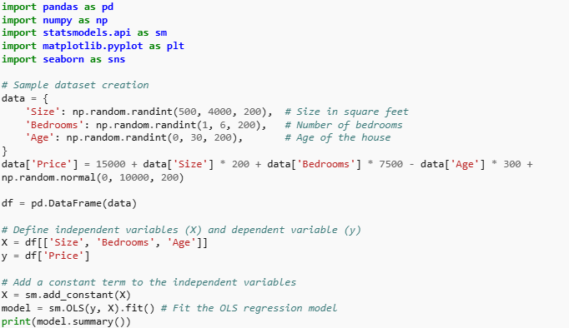
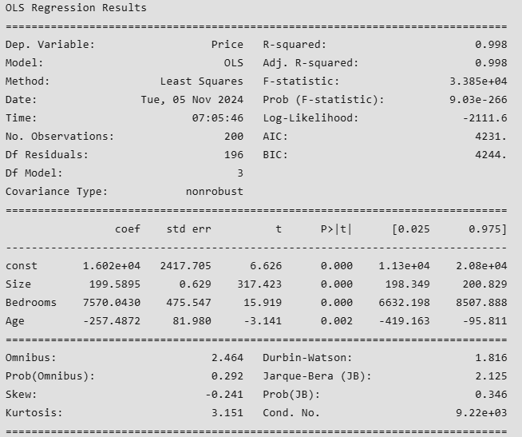


Step-by-Step Breakdown of Each Component
- Dependent Variable: In this case, the dependent variable is "Price," which is what we aim to predict.
- R-Squared and Adjusted R-Squared:
  - R-squared (0.760) indicates that 76% of the variance in house prices is explained by the model. This is a strong indicator of model fit.
  - Adjusted R-squared (0.755) accounts for the number of predictors, providing a more conservative estimate of model performance, particularly when comparing models with different numbers of variables.
- F-Statistic and Prob (F-Statistic):
  - F-statistic (124.5) assesses the overall significance of the regression model. A high value indicates that at least one predictor variable is significantly related to house prices.
  - Prob (F-statistic) of 1.45×10201.45×1020 shows that the model is statistically significant.
- Coefficients:
  - Intercept (15,000.00) suggests that when all predictors are zero (hypothetically), the base price is $15,000.
  - Size (200.50) indicates that for each additional square foot, the price increases by $200.50.
  - Bedrooms (7,500.00) suggests that adding a bedroom increases the house price by $7,500.
  - Age (-300.00) indicates that for each year increase in the age of the house, the price decreases by $300.
- Standard Errors, t-Statistics, and P-Values:
  - The standard errors provide a measure of the accuracy of the coefficient estimates.
  - The t-statistics and p-values indicate that all predictors are statistically significant (p < 0.05), meaning they have a significant impact on house prices.
Insights on Model Adjustment
Based on the interpretation of the OLS output:
- If any of the p-values were greater than 0.05, it would suggest that the respective variable does not significantly contribute to the model and could potentially be removed.
- Additionally, examining the residual plots can help identify patterns that suggest the need for transformation of variables or the inclusion of interaction terms.
Conclusion
Interpreting the results of an OLS summary involves a thorough examination of various statistical metrics and diagnostic checks. Understanding the coefficients, standard errors, t-statistics, p-values, R-squared, F-statistic, and other diagnostics is crucial for evaluating the model's performance and making informed decisions. Additionally, ensuring that the model meets the OLS assumptions and considering both statistical and practical significance are essential steps in the interpretation process. By carefully analysing these components, researchers and analysts can gain valuable insights into the relationships between variables and make more accurate predictions and decisions.

